Assignment 1:

Write xpath for below elements using below html webpage screenshot & html

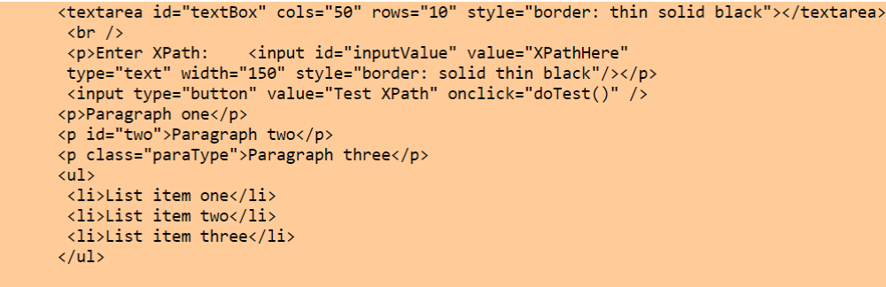

1. Textbox (large one)

- //br[@textarea id=’textBox’]
- //br[text()=’thin solid black’]
- //*[@textarea id=’textBox’]

2. Button (Test Xpath)

- //p[@value=’Test XPath’]
- //p[text()=’doTest’]
- //p[contains(@input type, 'button')]

3. Label with text Paragraph one

- //p[2]
- //*

4. Label with text Paragraph two

- //p[@id=’two’]
- //p[3]

5. 2nd element of list i.e. List item two

- //ul/li[2]

6. Textbox with value XpathHere

- //p[@value= ‘XpathHere’]
- //p[text()=’ XpathHere]
- //p[contains(@value, 'button')]
- //*[@value= XpathHere’]

Note: Write at least 3-4 xpaths for above
HTML Code

Assignment II:
Consider the following HTML code snippet
<table>
<tr>
<td>3</td>
<td>4</td>
</tr>

<tr>
<td>1</td>
<td id=”Test”>MSSquare</td>
<td>2</td>
</tr>
</table>

- a. Below xpath is pointing to which text field?

//table/tr[1]/td 3

- b. Write at least 3 Xpaths for value 2 (using relative xpath of id=test)

